Aiden Inglis

NMIT  322 Hardy St Nelson 7010

DAT602 – Assignment 1

# Milestone 1

## Game Description

### Base Idea

My idea for a multi-player game is an adventure, turn based game where the players will move around the map and fight a monster to win the game while picking up equipment and items along the way to make them stronger. The game will be max 15 minutes and the players that survive(if they survive) by the end of the game after the monster dies wins (+1 point). If the players die, they lose 1 point from their score.

### Logging In

When the game is first started the player will be faced with a log in screen where the player will have to enter their username and password to enter into the lobby which will be checked against the database. If they don’t have an account they can click the “don’t have an account” link below and then make an account to log them in with(which the account will be created then checked against the database that it exists. If the user fails their password 5 times in a row then the player will be locked out and will need to contact an administrator to have them unlock it. When registering a new account the user will be required to make a username, password, and enter their email.

### Game Lobby

Once players have registered and logged into their account, they will be directed to the lobby. In the lobby the user will be able to see the online players and active games listed. In the lobby users will be able to create games, log out, join an existing game. For administrators, if a user has administrative rights, then they have some extra buttons in addition to normal plays as they can shutdown games, create user, update user, delete user. In the lobby, if the user wants to create a game, they will have the choice of picking between two maps in which the boss and the items are different. The player will have a button that will allow the player to delete their own account. (admins will not be able to use this feature).

### Gameplay

When users start a game, on the left panel they will see what equipment they have and in the middle top of the screen they will be able to see whose turn it is. Each turn the player will be able to move one tile.

#### Players Movement and Items

When it comes to the gameplay the players will be restricted to a 10 by 10 grid in which they can move around in. The players will start in the same tile and each game will have a max player count of four at one time. Players may move around the board picking up items and equipment before fighting the boss/monster. If a player’s turn takes longer than 3 minutes then their turn is skipped.

#### Monster Combat

a player can encounter a monster on a tile. If they do then they will engage in combat with the user. This will be turn based with the player and monster, so when the player moves to the tile, they will then have to attack the creature, or do nothing, the monster will then do one thing which is attack and deal damage to the player/s in its square. The player deals base damage and then additional damage with effects/equipment. Players may choose to use items that are in their inventory at any time.

#### Objectives and scoring

**Objective:**

The main objective of the game is to go into combat with the monster and then kill it to win. You may divert from this goal by getting equipment and items along the way.

**Scoring:**

There will be a scoring system based off of how many games the user has won and lost.

It is going to work like this:

If player dies: -1 point

If player leaves the game before its finished then no change.

If the player is in a game when the monster dies: +1 point

These points will be shown in the lobby as a sort of leaderboard for active players(meaning only the active players’ scores will be shown.

If the game takes longer than 15 minutes the game ends and no points will be changed.

### Administrators

Administrators in this game will higher privileges than normal users as they will be able to do things like end active games, modify/delete users registered users, and lock/unlock registered accounts. An administrator’s job is to monitor the lobby and reply to requests and act on those requests if necessary (actions will be made upon their own volition).

## Storyboards

### Player registration.

The player will launch the application and then be faced with the login screen, if they do not have a login yet they will have to make one.

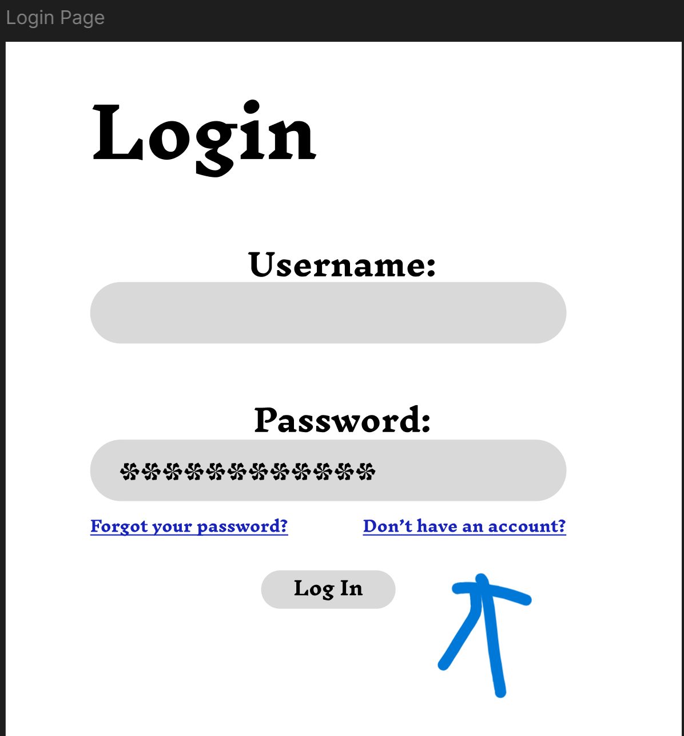

They will be redirected to the registration page in which they will enter their email, and make a username and password.

They will then press the registration button after the users details have all been entered correctly.

The player will then be logged in and sent to the lobby.

### Player login, including lock out, Failed.

So this user is trying to login. He will first add his username and password into the inputs below and press the “login” button.

If the password or user name is wrong then they will get this page.

Or User not found if the username isn’t found in the database.

If you have failed a users password 5 times then the user account will be locked and user will be shown this screen below.

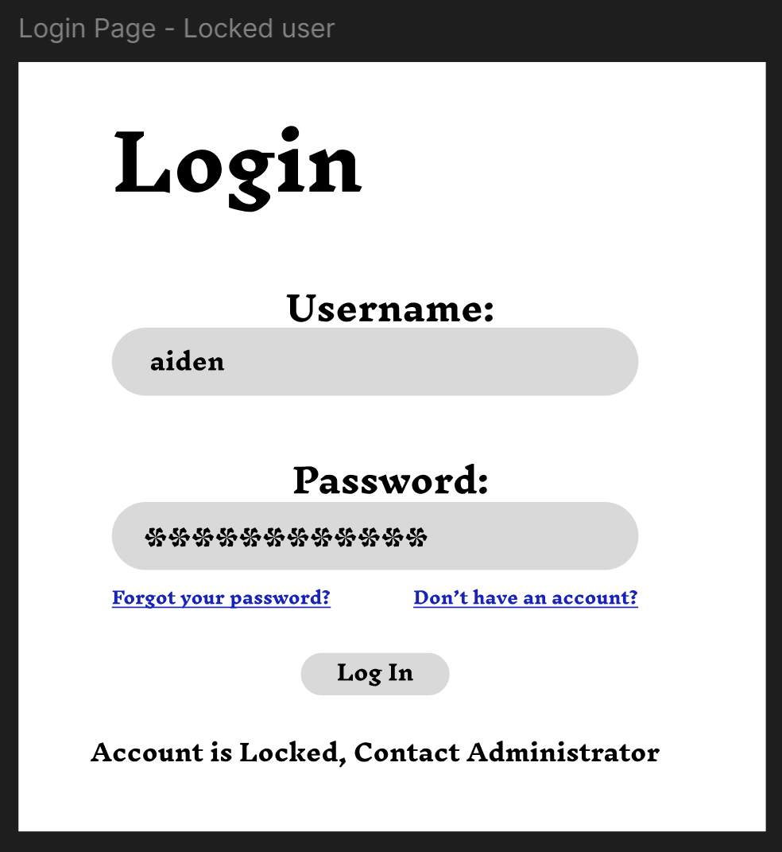

### Player deletes own account.

So A player will log in with their account and start in the lobby as demonstrated before in the player registration.

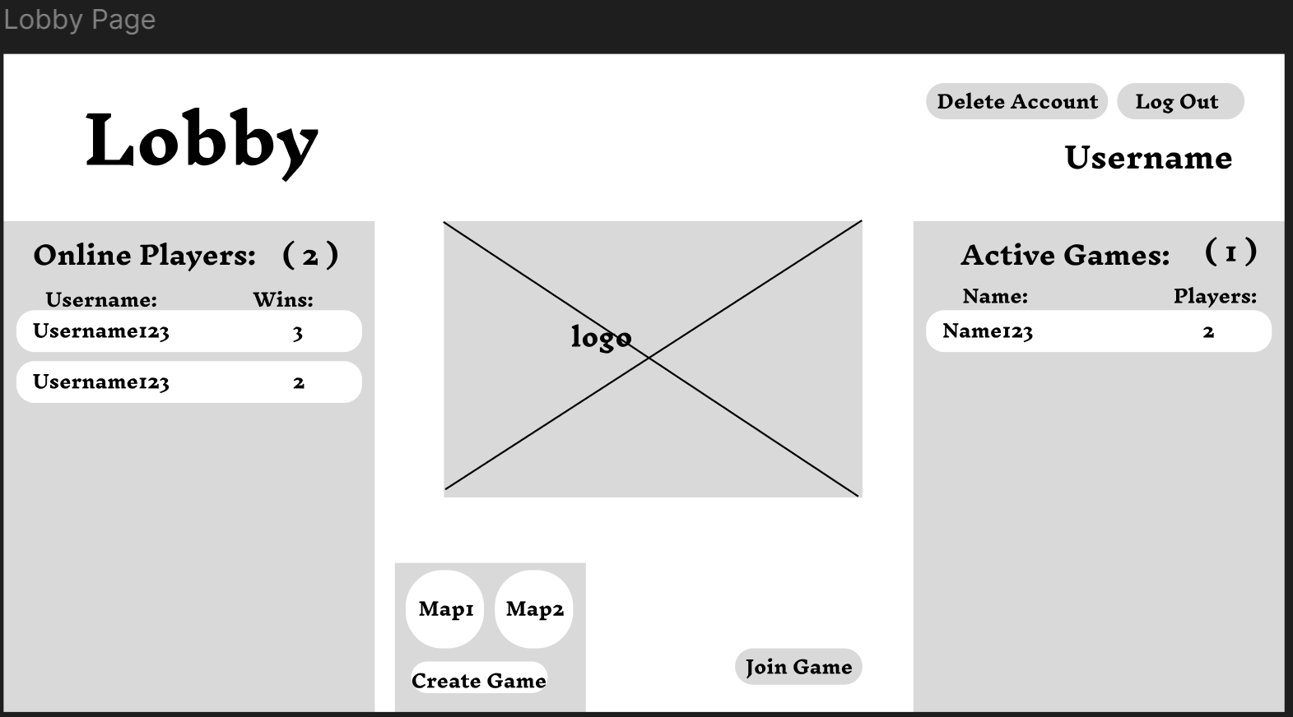

They will then click the button at the top of the screen second to the right which says ‘delete account’.

The player will then get a confirmation window and if they select yse then their account will be erased from the database.

### How to join a game.

To join a game a player must either click the join matches from the lobby which are located on the right side. Another method that the player can use is creating a game in which they can choose between two maps and then must click create.

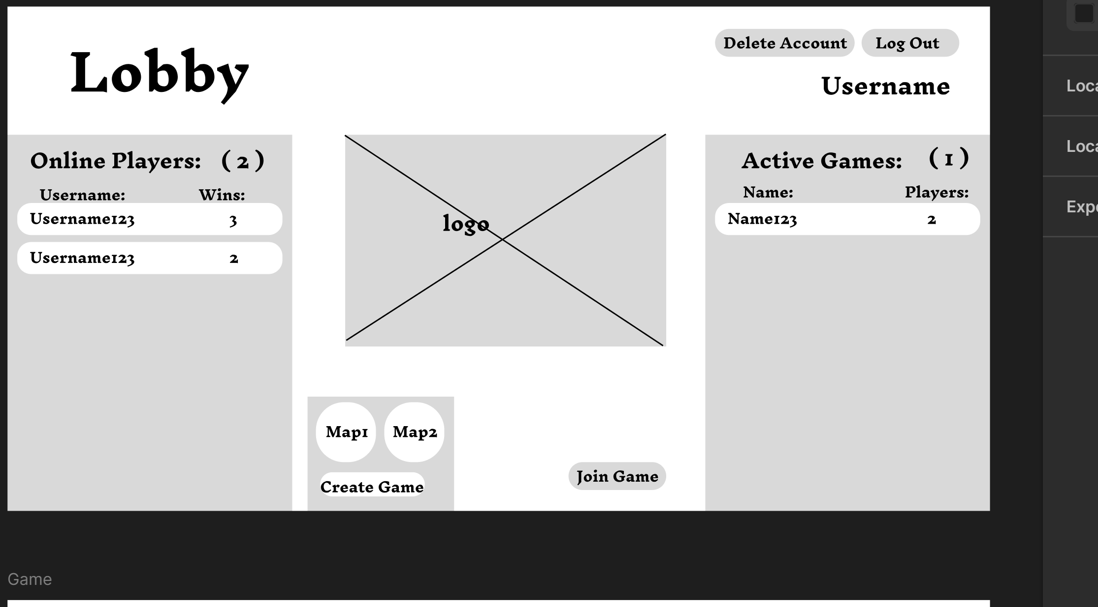

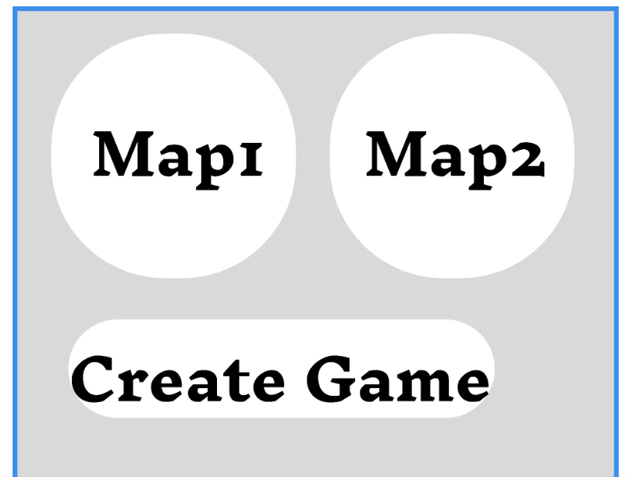

After the player has pressed create, they will then be taken to a new game with their specified map.

### Picking up an item on a tile.

When the player has moved to a spot with a yellow background the pickup option becomes available and then the player can click on that button and then a item will be picked at random from a pool of items and will then be available in the players inventory.

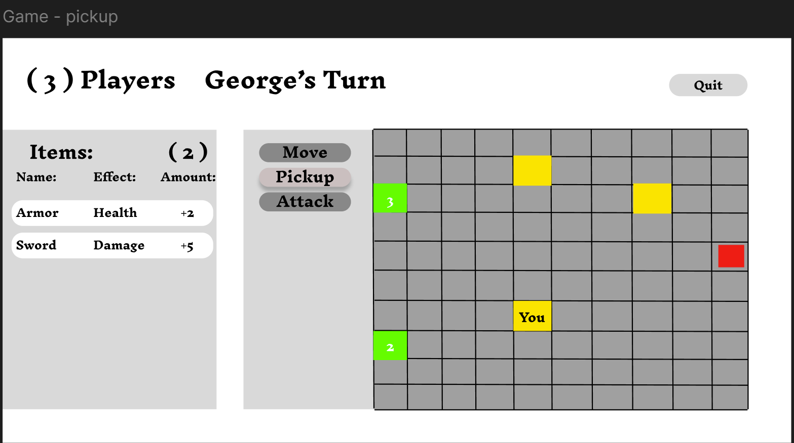

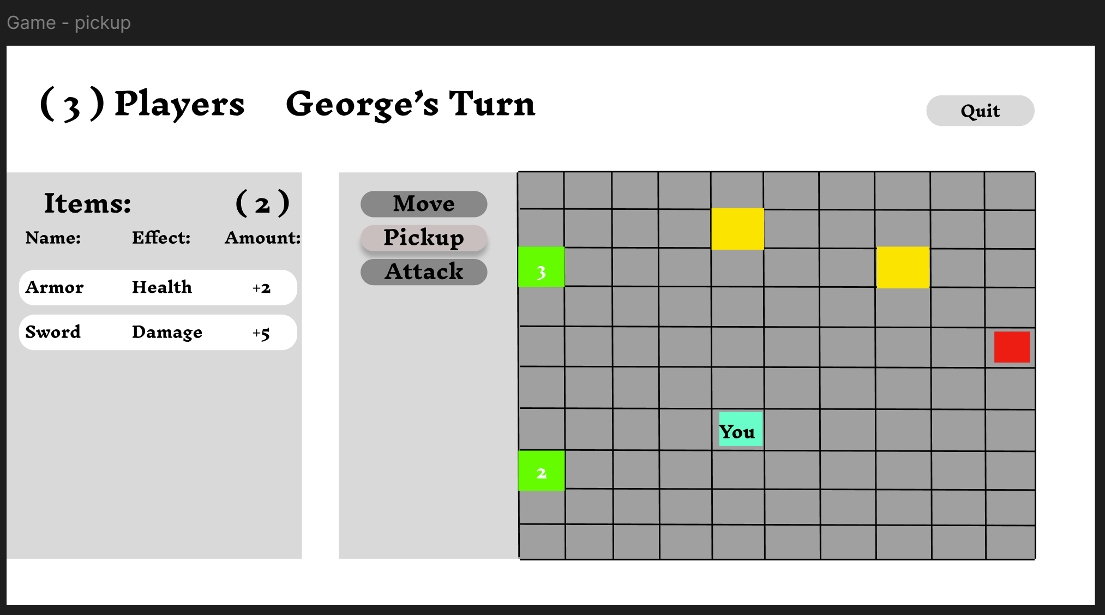

Once an item is picked up you would see a item/s on the left.

### Player - game play movement

When it is your turn you can select the move option and then click any tile adjacent to you(these tiles will be shaded differently) and once you click on a tile you will be moved there. In this example I will head towards the boss.

### Admin – Delete player account

First the Admin must click on a user account found in the left pane.

Then the Admin must click on the ‘delete user’ button and then a popup will ask for confirmation.

The admin could then click on the yes button on the right botton of the popup. If so the account will be deleted from the database. If they click ‘no’ then the popup will be closed and then nothing will happen.

### Admin – Create player account

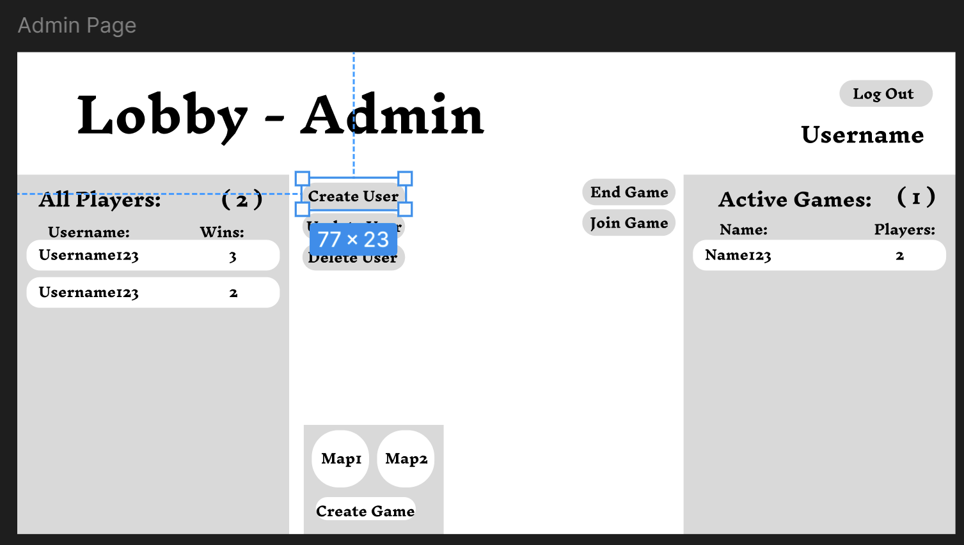

To create a user account the admin must click on the ‘create user’ button.

After they clicked that button, a will face a popup which will ask for confirmation, if yes then the admin will be logged out and then the user will be sent to the registration page.

In which they will enter the new user account’s username, email and password and will then press create user and then the user will have been created successfully.

### Admin – Update player account

The admin will log in and be in the admin lobby. The admin will select any user on the left pane by clicking on them. They will then click on the update user button.

If yes a window will pop up and then the admin can edit the details of the user.

Then the admin once they have made their changes by changing the inputs, clicking reset password which will change the password of the user to what, then all they need to do is to click update.

### How Combat works

Combat is really simple, once you are in a tile adjacent to a monster you are able to use your attack button. You can then click attack then click the monster. The monster health and player health is displayed at the top of the screen in a popup, in this popup you can then confirm the attack or not, in which if you confirm the moster will be dealt damage equal to the player strength and the same the other way around. The interaction of combat is now done for the players turn.

The player can click x and then the attack phase has ended for their turn.

### How to end your turn

To end your turn click the end turn button on the Bottom left of the game screen. You may click this button at any point on your turn. It will then skip to the next persons turn.

### How Chat works

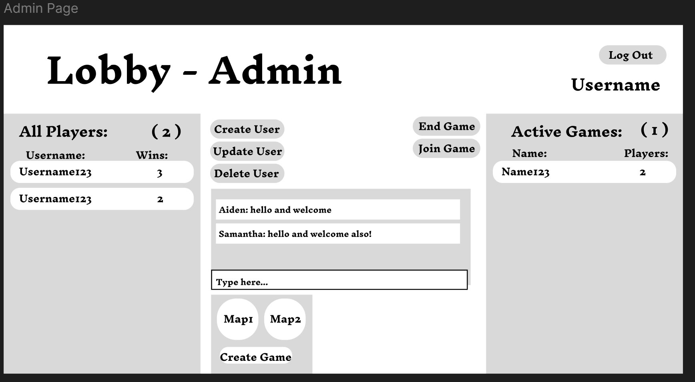

The chat system is simple, you type your message into the input and then press the enter key on your keyboard.

Your message should show up on the listbox above for all the players in the lobby to see.

### How to log out.

On the top right side of your screen in the corner of the lobby, there is a button labelled ‘logout’. If you click this button you will then be logged out and redirected into the login page.

## Entity Relationship Diagram

## CRUD Table

|  |  |  |  |  |  |  |  |  |  |  |  |  |  |  |  |  |  |
| --- | --- | --- | --- | --- | --- | --- | --- | --- | --- | --- | --- | --- | --- | --- | --- | --- | --- |
|  |  | Check username in DB | Reg new user | Check password against username | Lock account | Login accepted | Join existing game | Start game | Game ends | Player moves | Combat | Player quits Game | Player logs out | Admin kill game | Admin edits existing player | Picking up an item | Admin Delete User |
|  |  |
| Player |  | R | C |  |  | R | R | R | RU | R | R | R | R |  | RU | R | D |
| Player ID |  | C |  |  |  |  |  |  | R | R |  |  |  | R |  | D |
| Username | R | C | R | R | R | R | R | R |  |  | R | R |  | RU | R | D |
| Password |  | C | R |  |  |  |  |  |  |  |  |  |  | RU |  | D |
| Email |  | C |  |  |  |  |  |  |  |  |  |  |  | RU |  | D |
| Locked User | R | C |  | U |  |  |  |  |  |  |  |  |  | RU |  | D |
| Login attemps | R | C | R, U |  | U |  |  |  |  |  |  |  |  |  |  | D |
| User in lobby | R | C |  |  | U | U | R, U | RU |  |  | U | U | U | RU |  | U |
| Player Score |  | C |  |  | R |  |  | RU |  |  |  |  |  |  |  | D |
| Admin user |  |  |  |  | R |  |  |  |  |  |  |  |  |  |  | D |
| Tile ID |  | C |  |  |  | C | C | D | RU | R | RU |  |  |  | R | D |
| Game ID |  | C |  |  |  | C | C | D | R |  | RU |  |  |  | R | D |
| Health |  | C |  |  |  | C | C | D |  | RU | R |  |  |  | RU | D |
| Strength |  | C |  |  |  | C | C | D |  | R | R |  |  |  | RU | D |
| Game |  |  |  |  |  |  | R |  |  |  |  |  |  | D |  |  |  |
| Game ID |  |  |  |  |  | R | C | D |  |  |  |  | D |  | R |  |
| Map |  |  |  |  |  | R | C | D | R |  |  |  | D |  | R |  |
| Game Status |  |  |  |  |  | R | C | D |  |  |  |  | D |  |  |  |
| Turn |  |  |  |  |  | R, U | C | D | R |  | RU |  | D |  | R |  |
| Item |  |  |  |  |  |  | R | C | D |  |  |  |  | D |  |  |  |
| Item ID |  |  |  |  |  | R | C | D |  |  |  |  | D |  | R |  |
| Tile ID |  |  |  |  |  | R | C | D |  |  |  |  | D |  | R |  |
| Status |  |  |  |  |  | R | C | D |  |  |  |  | D |  | RU |  |
| Monster |  |  |  |  |  |  | R | C | D |  |  |  |  | D |  |  |  |
| Status |  |  |  |  |  | R | C | D |  |  |  |  | D |  |  |  |
| Health |  |  |  |  |  | R | C | D |  |  |  |  | D |  |  |  |
| Strength |  |  |  |  |  | R | C | D |  |  |  |  | D |  |  |  |
| Tile ID |  |  |  |  |  | R | C | D | R |  |  |  | D |  |  |  |
|  |  | Loading messages | Tpying and sending a message |  |  |  |  |  |  |  |  |  |  |  |  |  |  |
| Chat |  |  |  |  |  |  |  |  |  |  |  |  |  |  |  |  |  |
|  | ChatID | R | C |  |  |  |  |  |  |  |  |  |  |  |  |  |  |
|  | Timestamp | R | C |  |  |  |  |  |  |  |  |  |  |  |  |  |  |
|  | text | R | C |  |  |  |  |  |  |  |  |  |  |  |  |  |  |

# Milestone 2

# Milestone 3